**SQL Queries and Answers**

**1 .To find max of sales price**

SELECT MAX(sale_price) AS highest_price from df_orders;

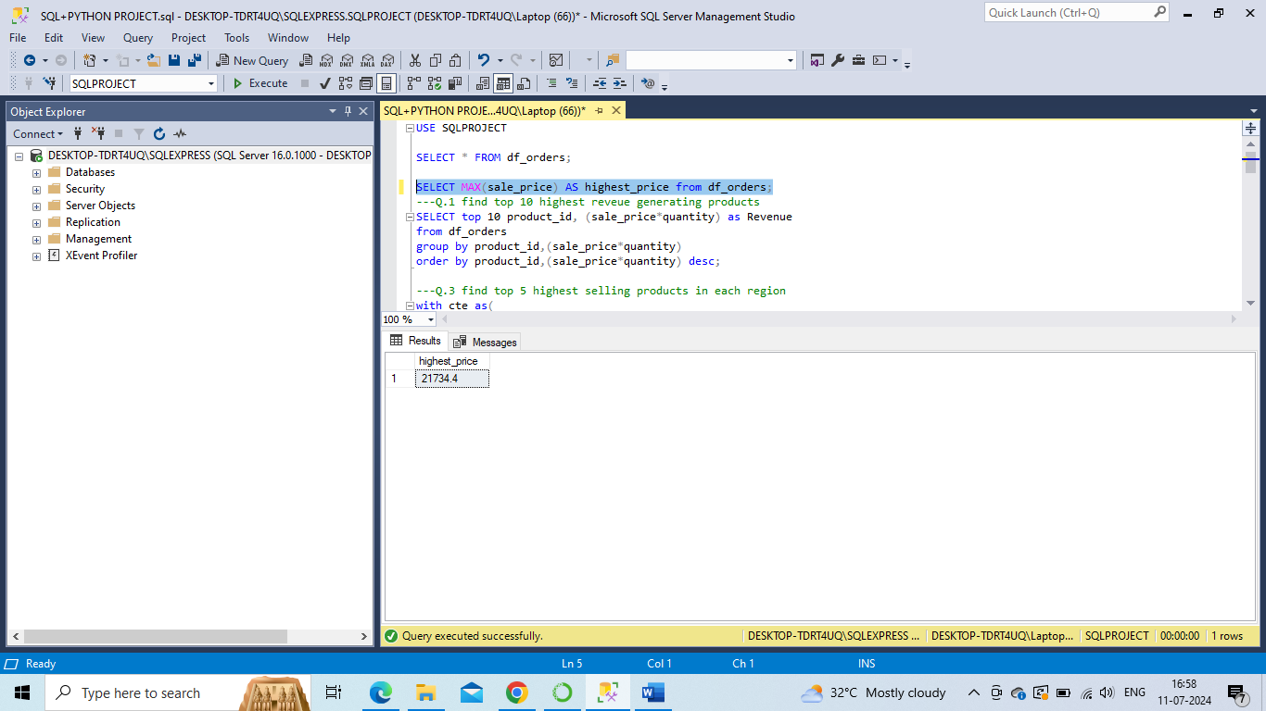

**2.** **find top 10 highest revenue generating products.**

SELECT top 10 product_id, (sale_price*quantity) as Revenue

from df_orders

group by product_id,(sale_price*quantity)

order by product_id,(sale_price*quantity) desc;

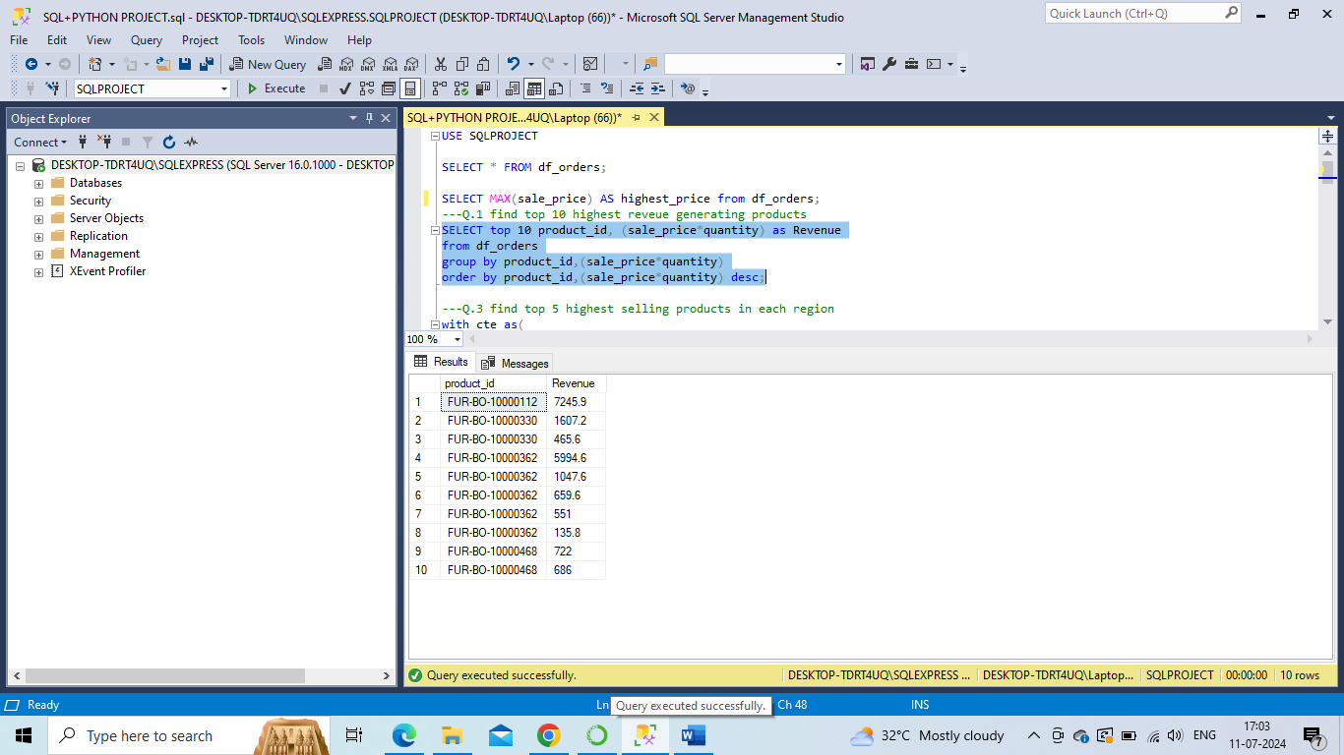

**3.** **find top 5 highest selling products in each region.**

with cte as(

SELECT region,product_id,SUM(sale_price) as Sale

from df_orders

group by region,product_id)

SELECT * from (

SELECT * ,

RANK()over(partition by region order by Sale desc) as RN

from cte) a

where RN <=5;

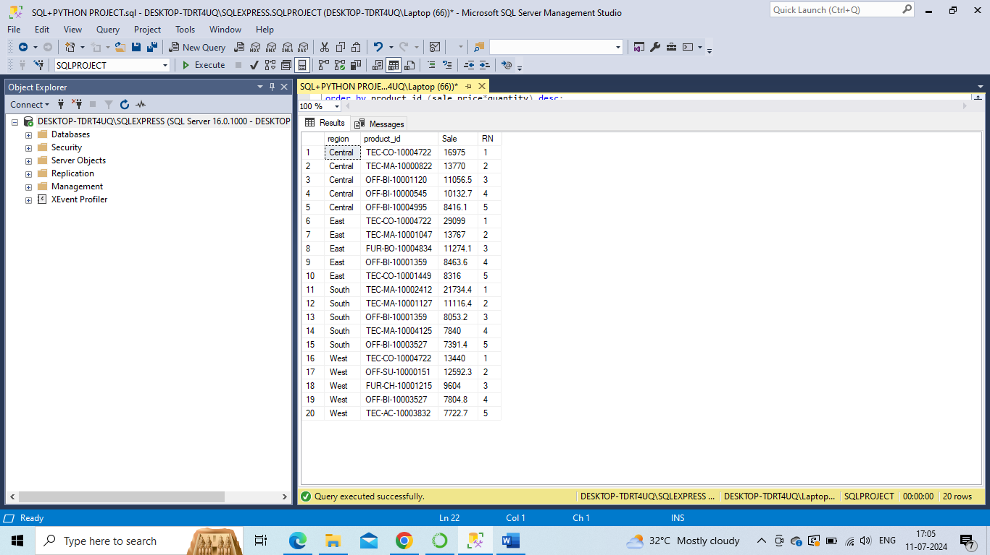

**4.** **find month over month growth comparison for 2022 and 2023 sales eg : jan 2022 vs jan 2023**

with cte as(

SELECT year(order_date) as order_year, month(order_date) as order_month,

SUM(sale_price) as Sale

from df_orders

group by year(order_date),month(order_date)

)

SELECT order_month,

SUM(case when order_year = 2022 then Sale else 0 end) as Sale_2022,

SUM(case when order_year = 2023 then Sale else 0 end) as Sale_2023

from cte Agroup by order_month;

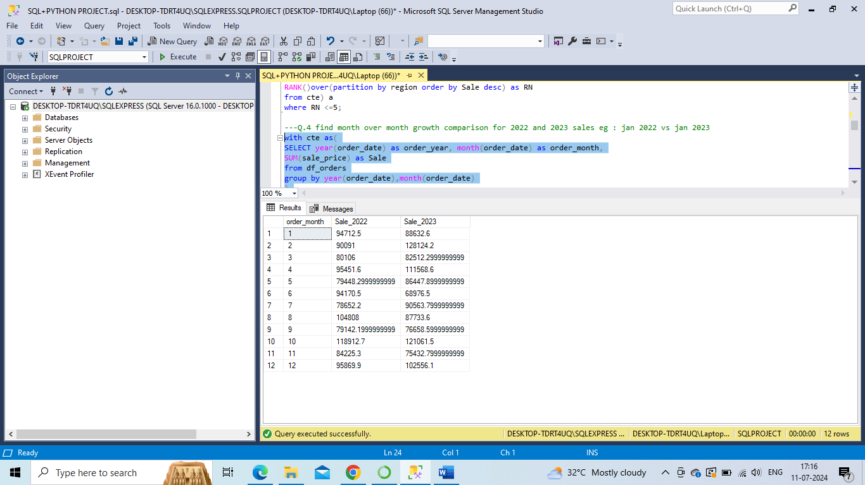

**5.** **for each category which month had highest sales**

with cte as(

SELECT category,format(order_date,'yyyy-MM') as order_month_year,

SUM(sale_price) as Sale

from df_orders

group by category,format(order_date,'yyyy-MM')

---order by order_month_year

)

SELECT * from(

SELECT *, row_number() Over(partition by category order by Sale desc) as rn

from cte )A

where rn = 1;

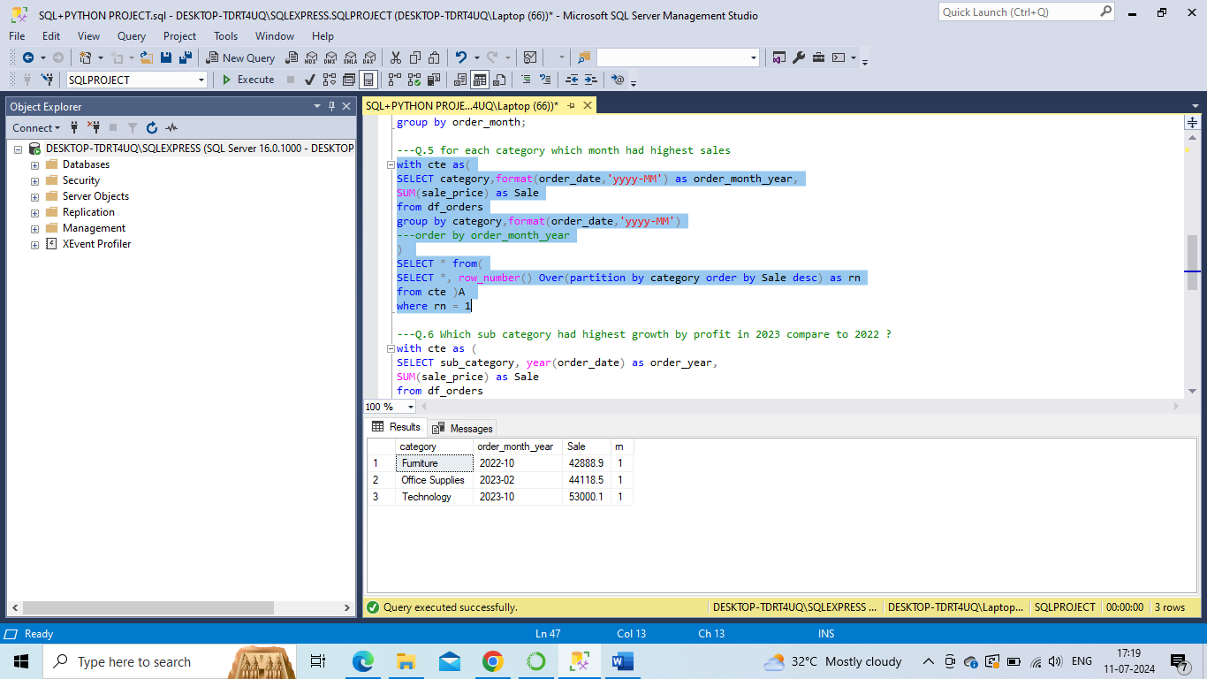

**6.** **Which sub category had highest growth by profit in 2023 compare to 2022 ?**

with cte as (

SELECT sub_category, year(order_date) as order_year,

SUM(sale_price) as Sale

from df_orders

group by sub_category,year(order_date)

)

,cte1 as

(

SELECT sub_category,

SUM(case when order_year = 2022 then Sale else 0 end) as Sales_2022,

SUM(case when order_year = 2023 then Sale else 0 end) as Sales_2023

from cte

group by sub_category

)

SELECT top 1 *, (Sales_2023 - Sales_2022)

from cte1

order by (Sales_2023 - Sales_2022) desc;

